Search != Maps

|  |  |  |  |
| --- | --- | --- | --- |
|  | **Backtracking** | **Use Enqueued List** | **Informed Search?** |
| British Museum | No | No | No |
| Depth First | Yes | Yes - Front | No |
| Breadth First | No | Yes - Back | No |
| Hill Climbing | Yes | Yes – Front; Sorted | Yes |
| Beam | Yes | Yes – Keep w best | Yes |

*Informed search – is it making use of any kind of heuristic information?

1. 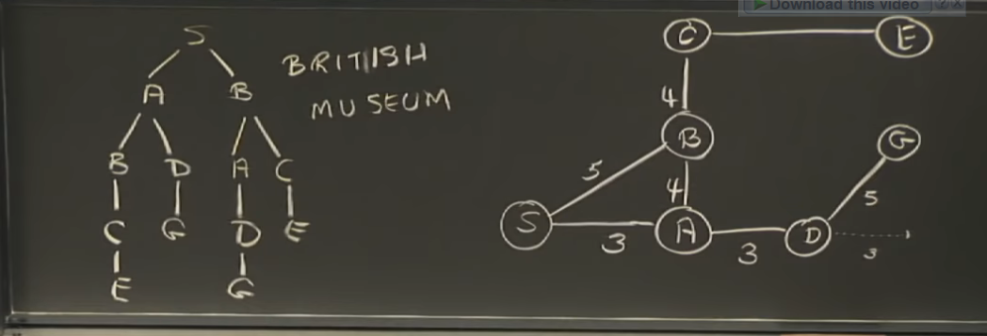British Museum (Generate and Test)
2. Depth First

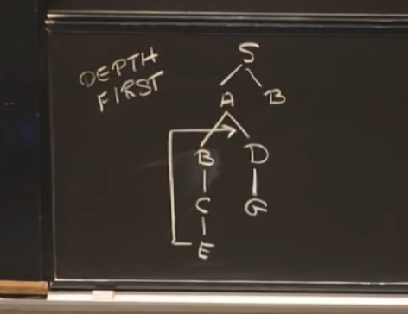

1. Breadth First

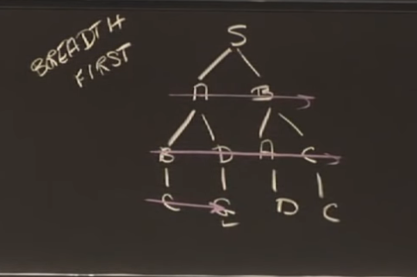

1. Hill Climbing

It's just like Depth-first Search, except instead of using lexical order to break ties, we're going to break ties according to which node is closer to the goal.

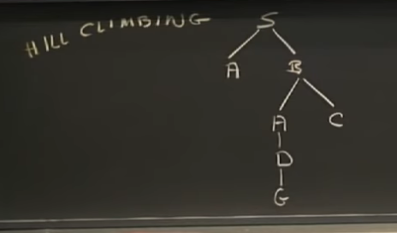

1. Beam Search

